Report
- On my part 1 my feedback was that I did not suppose the 2 proposals presentation so that is what I will be fixing and I will make sure to attach it to my folder in part 2.
- My second feedback was that I did not make the sizing of my pictures appealing as they differ in sizes and in this part of my assignment I tried to adjust the pictures to be almost the same size as they do not have the same width and height but I tried to adjust them to be almost equal in size.
- My issue with Part 2 it is that I don’t possess any tablet and I tried to find one so that I can attach the different sizes of my website as per assignment instruction but I only manage to find the screenshots for my phone and laptop.
The pictures below are the screenshots of how my website shows in a desktop.
This is the gallery page.
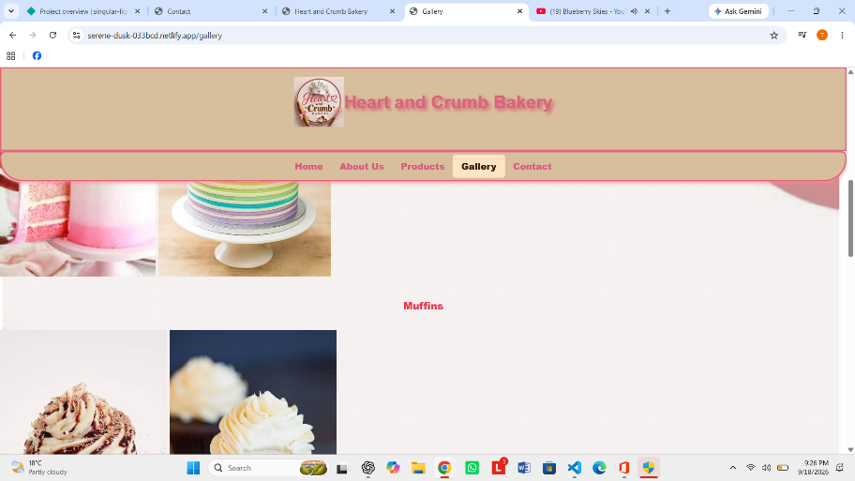
This is the about page
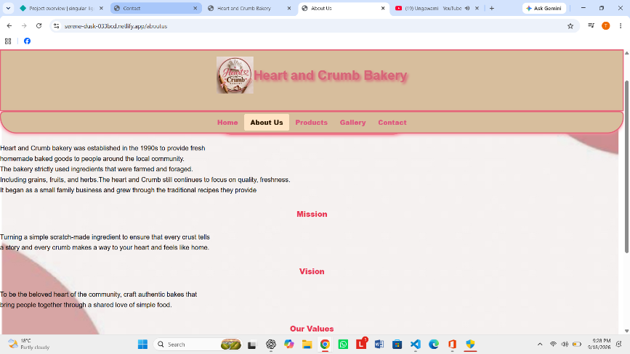
This is the home page
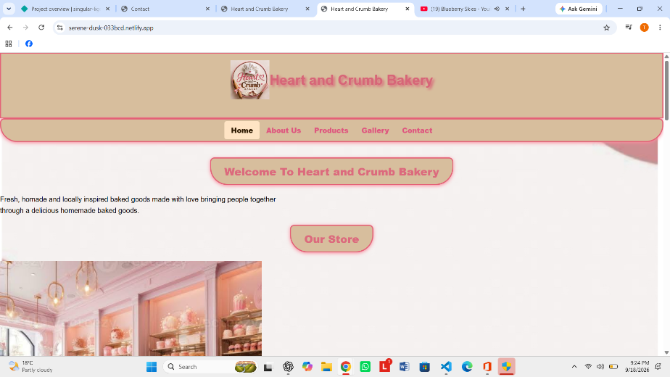
This is the product page
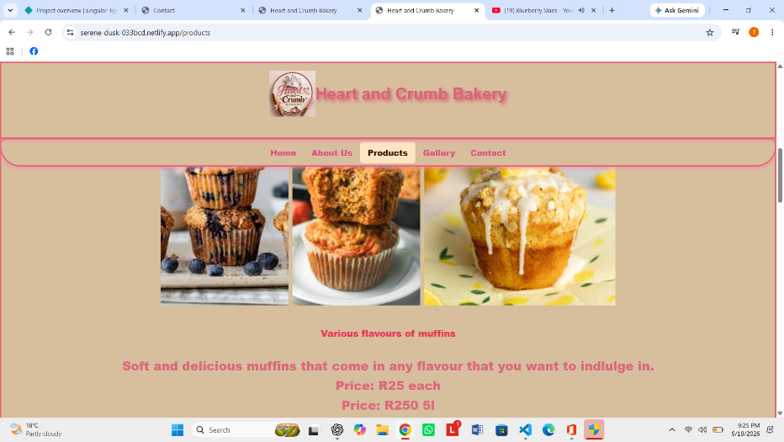
This is the Contact page.
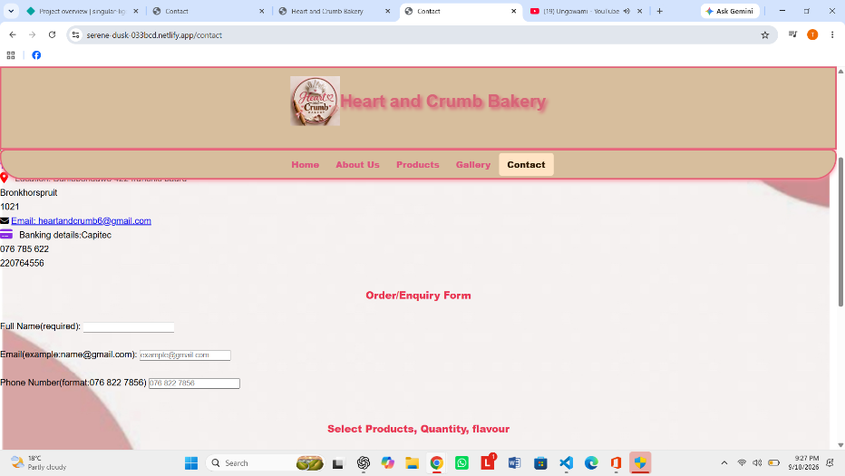

Then the pictures below is the view of how my website looks in a smart portable device.
